Description of Lab 6
- The program doesn’t require any input and the compiler used is MinGW.
Task 1:
Analytical Plot:
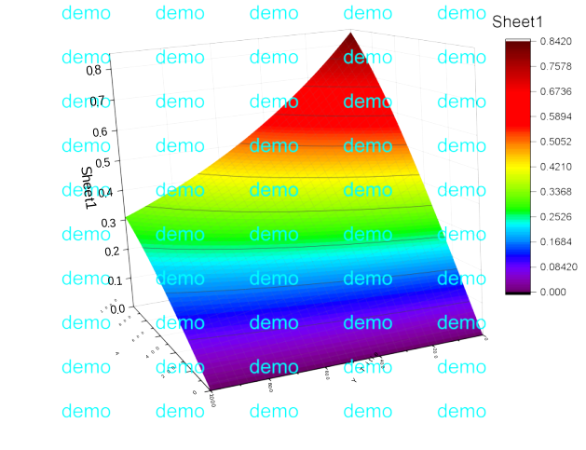
Numerical Plot:
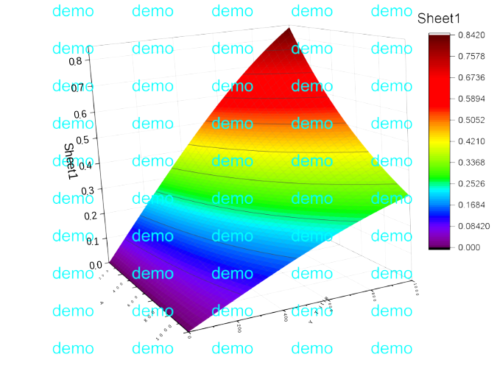
Thus, both plots can show similar results.
Task 2:
Gauss Law result: 0.00983755
Surface integral result: 0.01
Percentage error: 0.016%

